NORTHERN DISTRICT OF FLORIDA BANKRUPTCY BAR ASSOCIATION

2024 SEMINAR SPONSORSHIP FORM

Complete and return this with your check (made payable to the Northern District of Florida Bankruptcy Bar Association, Inc.) to: Shiraz Hosein

A check is enclosed for the following sponsorship level:

 | 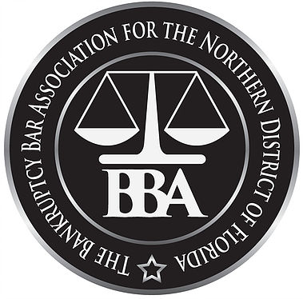  _____ Silver ($500) | _____ Gold ($1,000) | _____ Platinum ($2000)
Silver: This level of sponsorship includes recognition in the seminar promotional materials for the seminar, including a full-page advertisement in the materials and your logo listed on a sponsorship board at the cocktail reception.

Gold: This level of sponsorship includes one (1) ticket to the seminar, recognition in the promotional materials for the seminar, including a full-page advertisement in the materials and your logo listed on a sponsorship board at the cocktail reception.

Platinum: This level of sponsorship includes one (1) ticket to the seminar, one (1) opportunity to briefly endorse your organization to the attendees at the seminar, recognition in the promotional materials for the seminar, including a full-page advertisement in the materials and your logo listed on a sponsorship board at the cocktail reception.

Additional Options:

______ Platinum + Cocktail Reception Sponsorship ($1000 additional /$3000 total)
- Limited availability (one sponsor) – please contact in advance to confirm.
- Recognition as Platinum Sponsor and as Cocktail Reception Sponsor.
- Cocktail Reception Sponsor has the option of providing branded napkins, koozies or other cocktail-appropriate materials.

______ Platinum + Vendor Sponsorship ($500 additional / $2,500 total)
- Limited availability – please contact in advance to confirm.
- Recognized as Platinum Sponsor and Vendor Sponsor. Vendor Sponsors will be provided a booth near registration table at the seminar to distribute marketing materials. May also distribute materials at registrant tables before start of seminar. Will be provided a 2-4 minute opportunity to present products to full Bar Association during the seminar.

______ Gold + Vendor Sponsorship ($250 additional / $1,250 total)
- Limited availability – please contact in advance to confirm
- Recognized as Silver Sponsor. Vendor Sponsors will be provided a booth available near registration table at the seminar to distribute marketing materials. May also distribute materials at registrant tables before start of seminar.

Name or Firm Name:
________________________________________________________________________
Contact Person: ________________________________________________________________________
Mailing Address: ________________________________________________________________________
Phone Number: ________________________________________________________________________
E-mail Address: ________________________________________________________________________

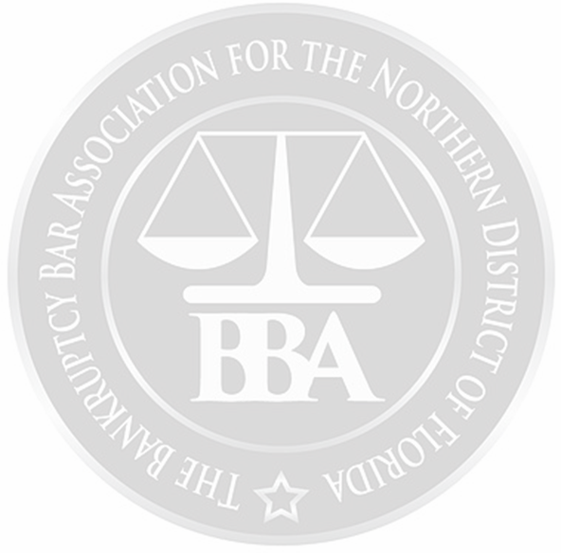

The Northern District of Florida Bankruptcy Bar Association greatly appreciates our sponsors at any level, we could not have our annual seminar without the support of our sponsors. We look forward to seeing you at the 2024 Annual NDFLBBA Seminar

